AWS : Amazon Web Service

Need : Previously we need to setup infrastructure like server, application host in 2005.

Challenges:

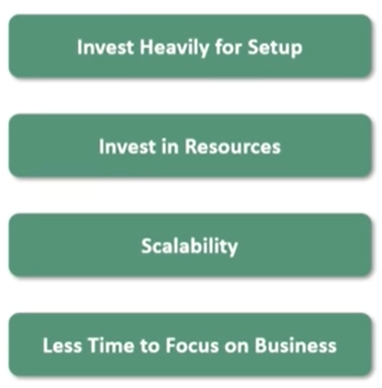

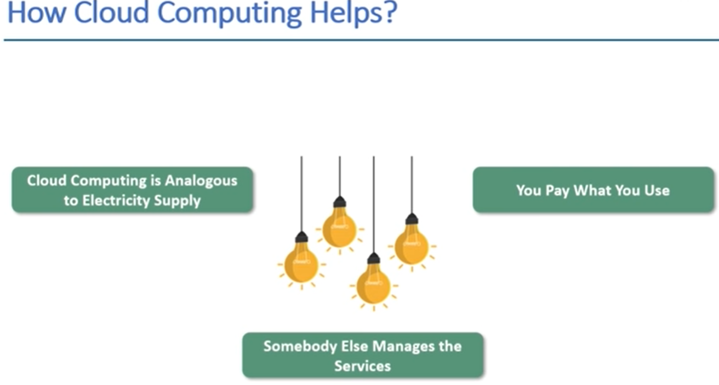

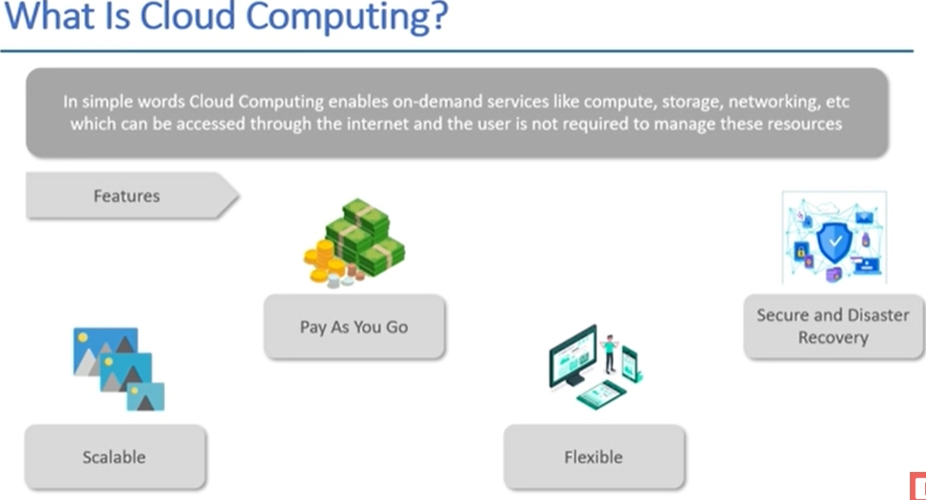

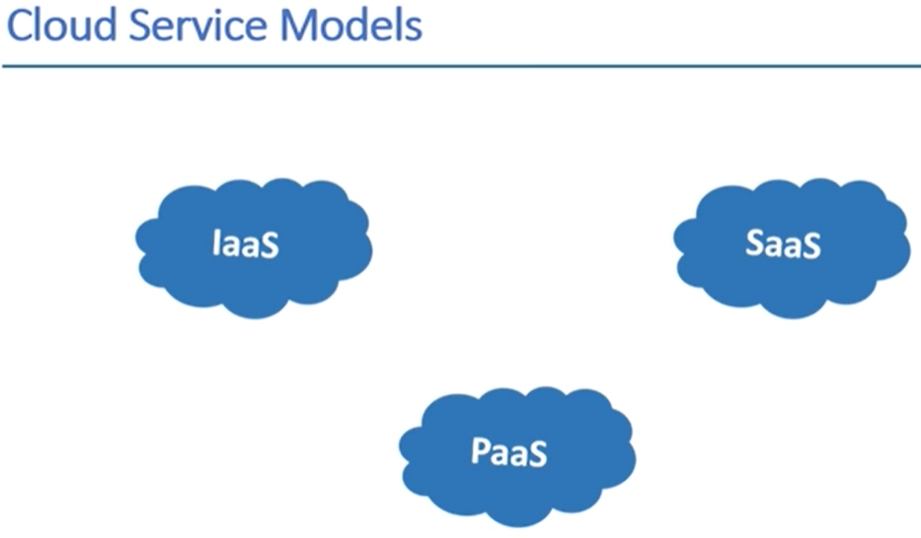

IAAS: Infrastructure as a service

We will manage everything own only provide infrastructure– network,security,storage and configuration etc.

PAAS: Platform as a service

Provide me platform so that I can run application for use.

SAAS: Software as a service

Provide me platform and run application as well – like gmail only use through internet not worry about how it is working.

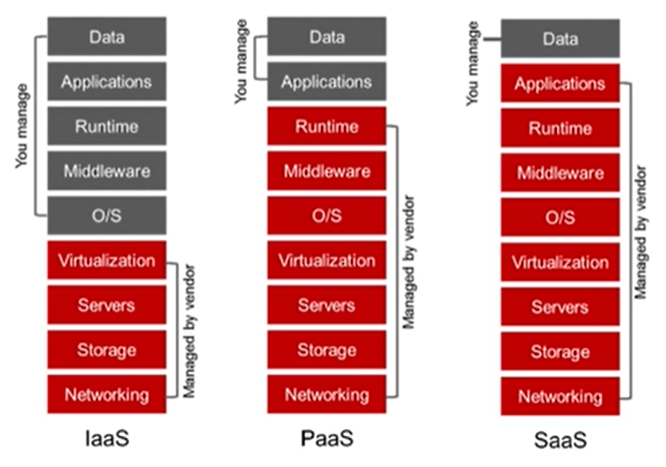

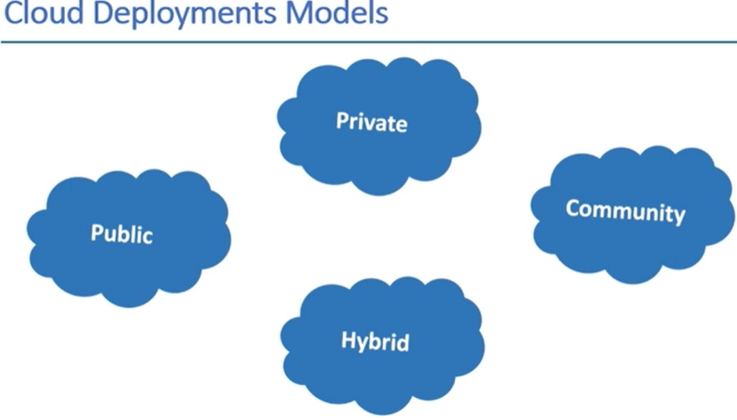

Public - if your data is not critical, your data on public data central, they keep your data isolated, cheap, other’s data also here

Private - if your data is critical use this, your data on private data central, costly, secure high, full isolated.

Hybrid – mixture of private & public – critical & non-critical data

Community – all branches come together and use community cloud for data handling.

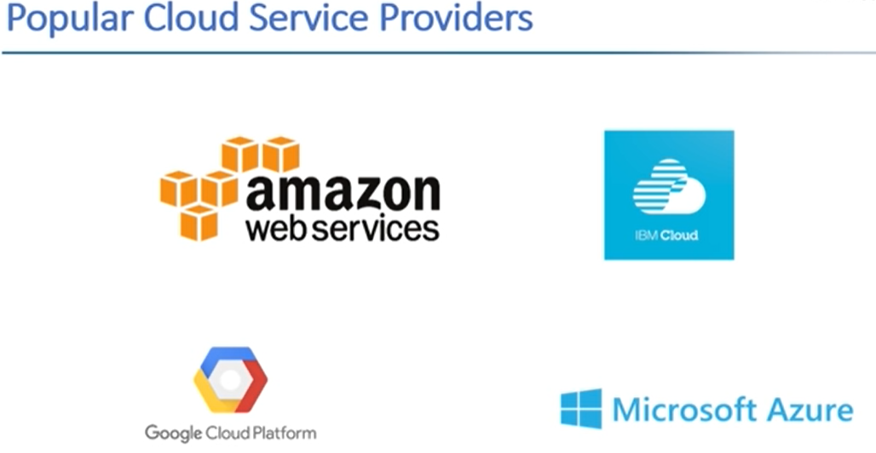

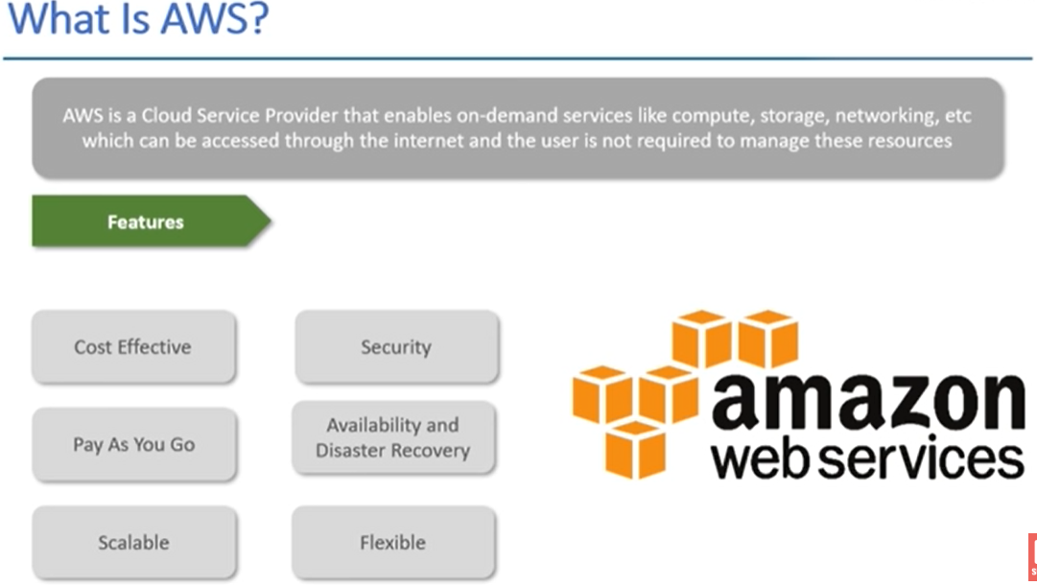

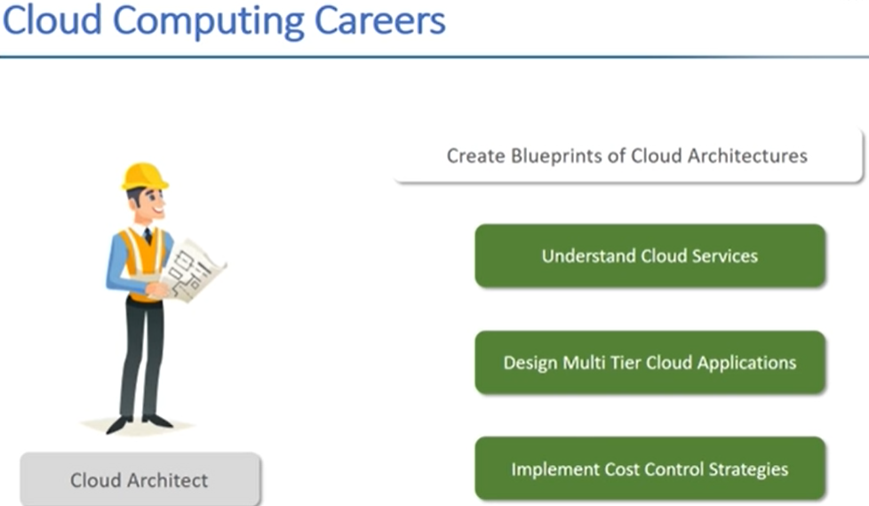

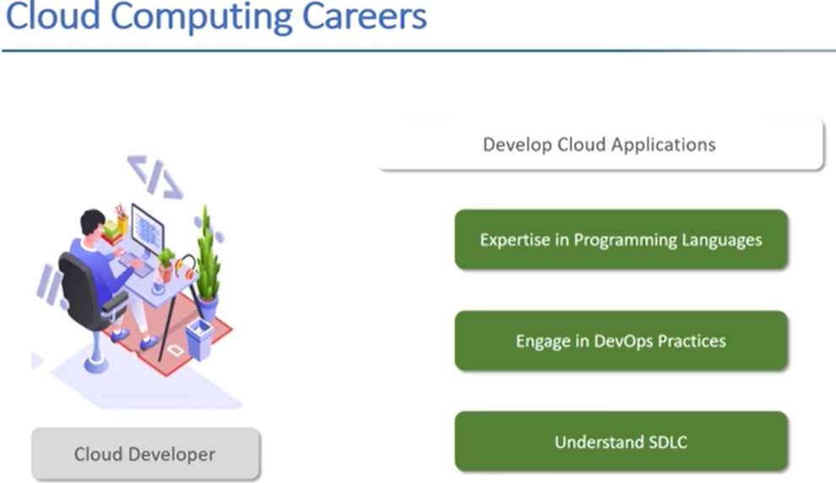

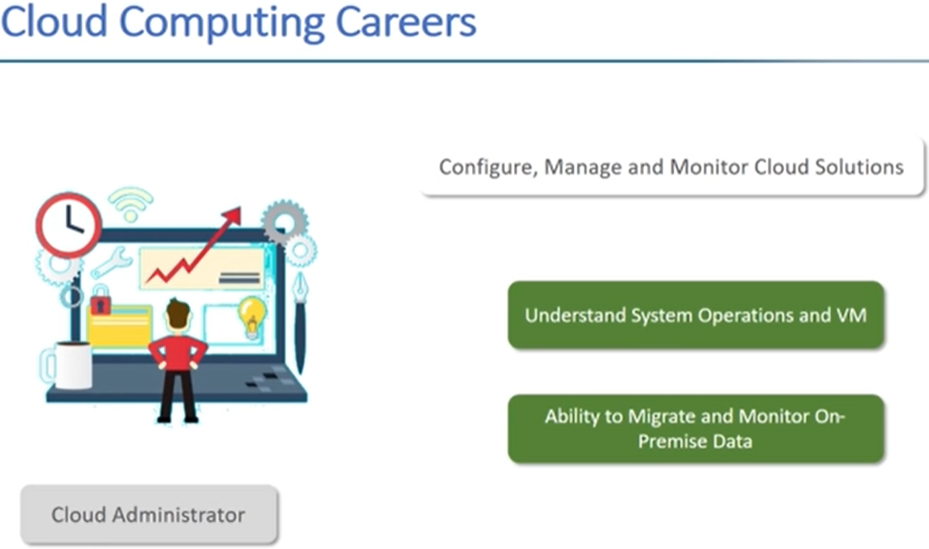

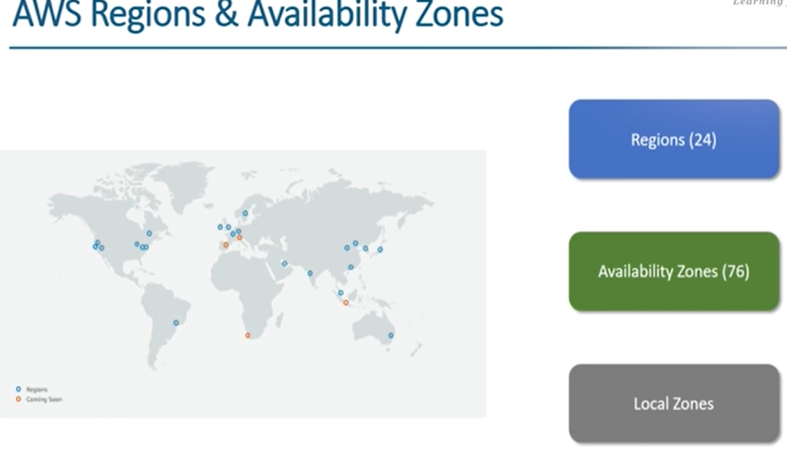

Regions – more than one data centre is there [ Mumbai ]

Availability zones – where exactly zones [ thane, Andheri,kurl ]

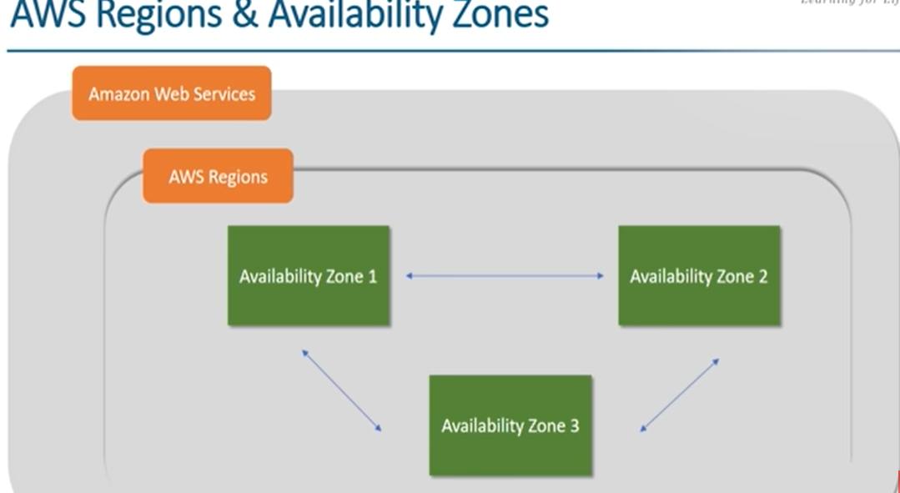

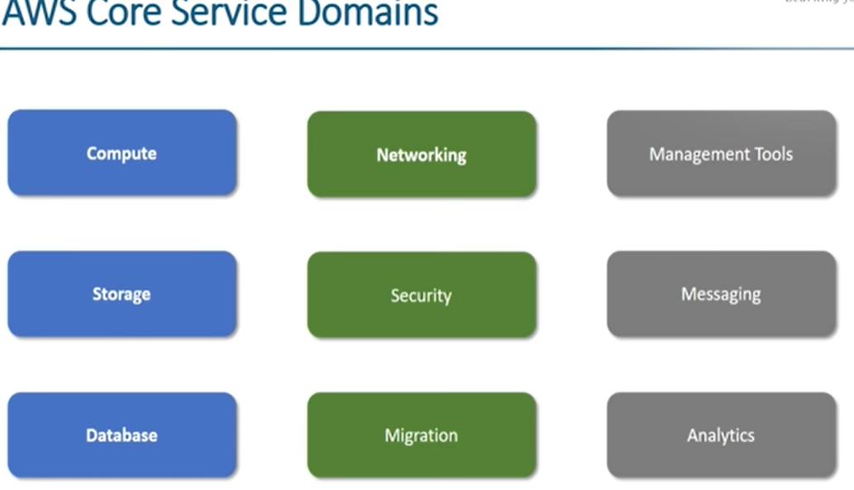

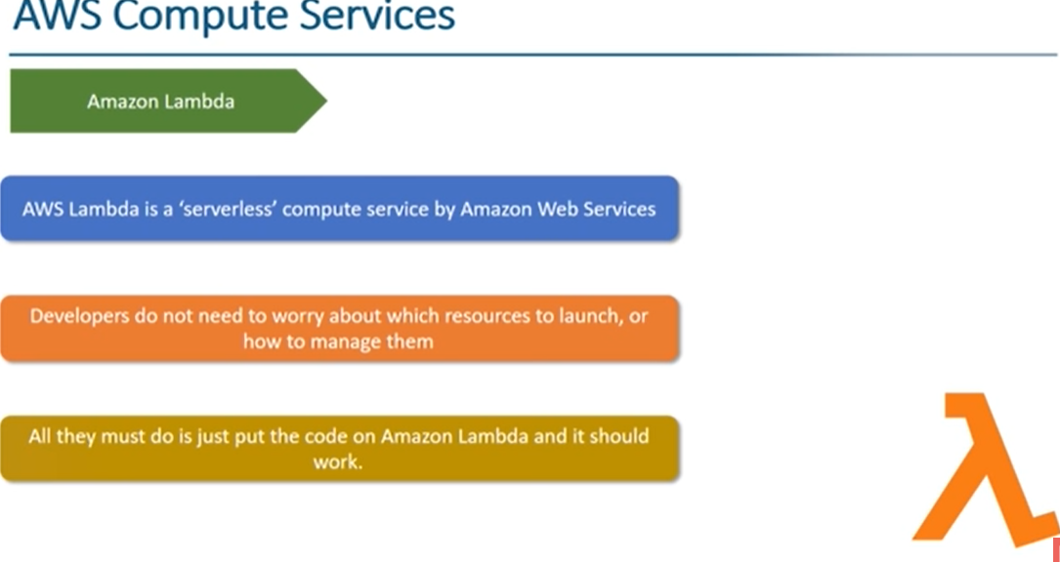

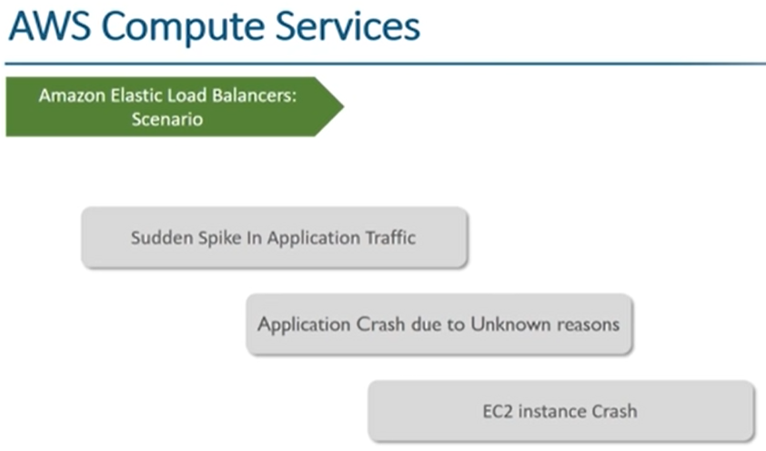

All load on instances is manage

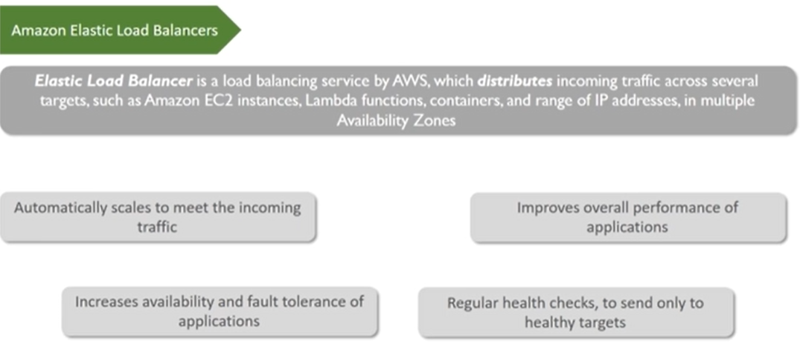

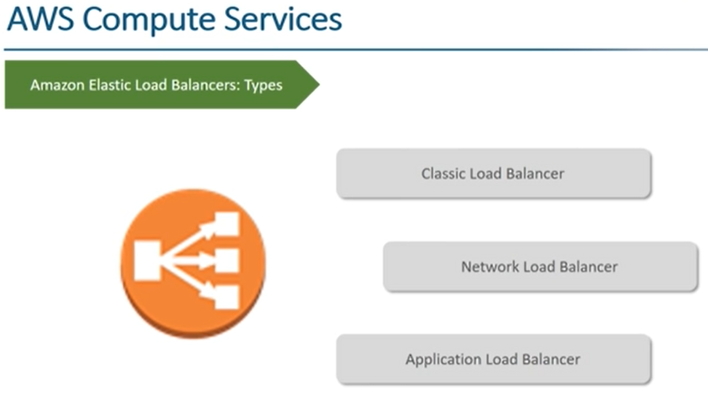

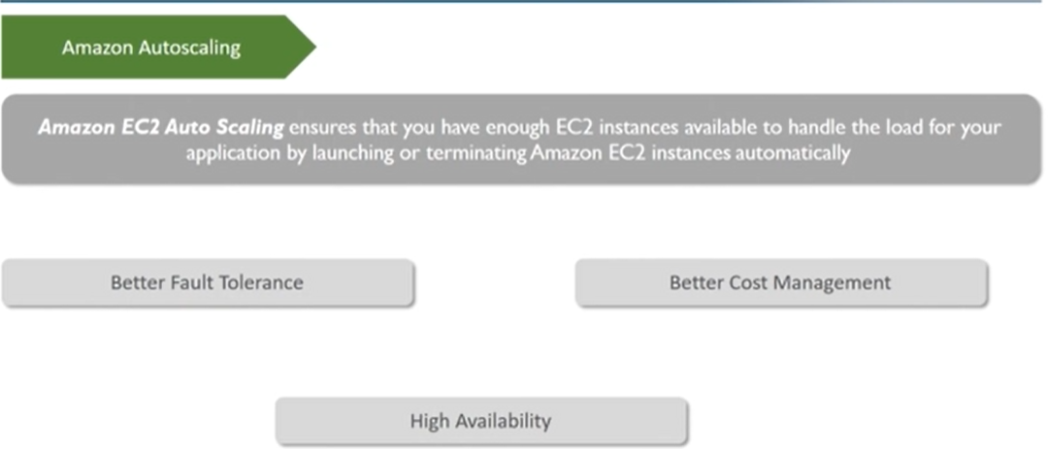

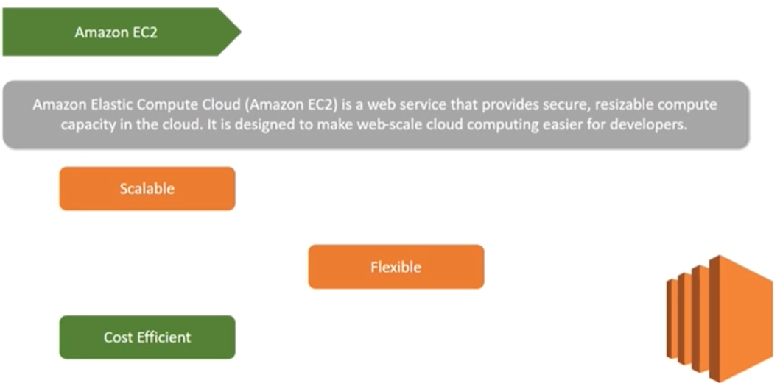

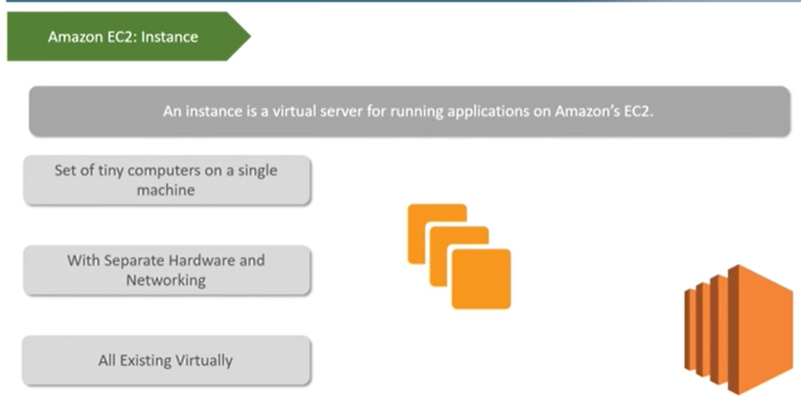

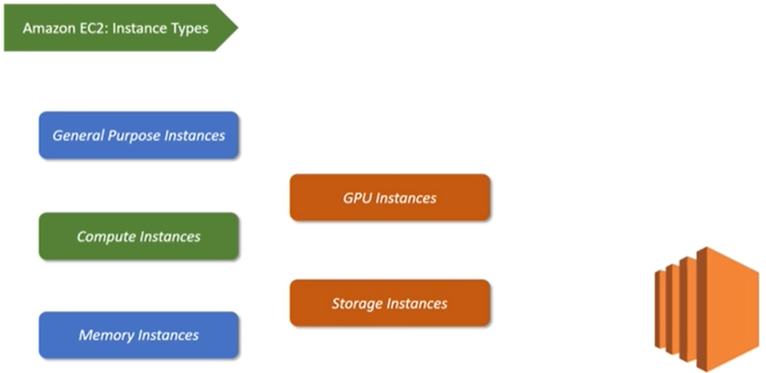

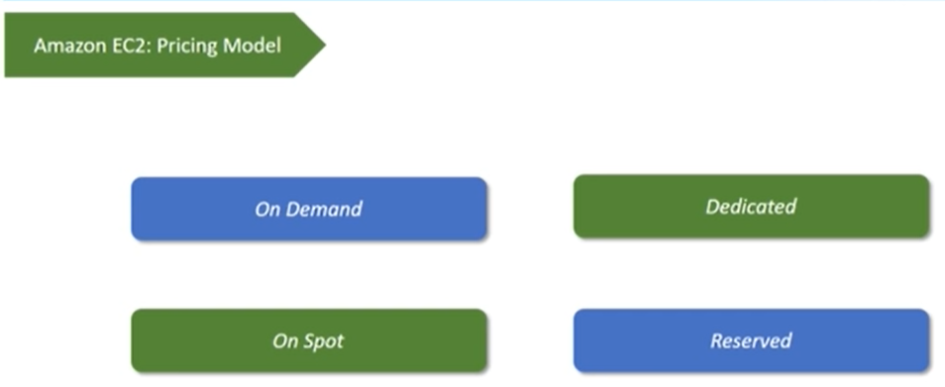

On-demand – want data consistent way on instance,

On-spot – like betting on instance has price, price changing

Dedicated – data critical secure

Reserved – reversed instance firstly later it will in less price

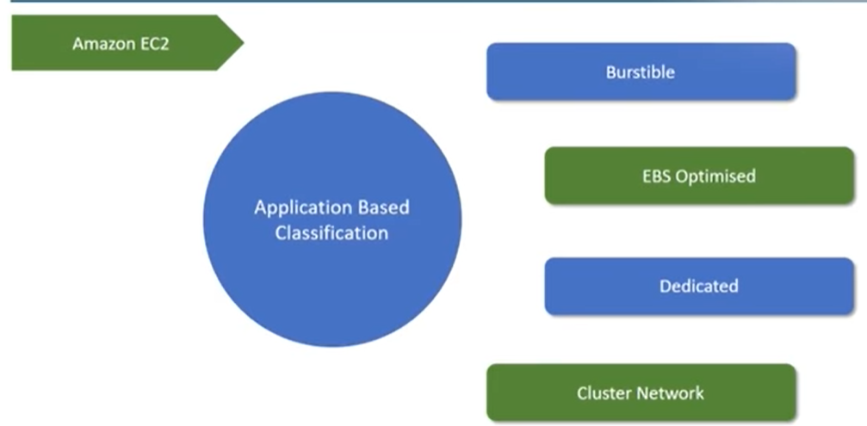

Burstible – used instance on optimize level – scale up & down your instance

EBS optimised – consistency on data in instance – like gmail

Dedicated – secure application

Cluster network – app works different area fronted and backend

Steps to launch EC2 :

1. Go to console EC2 and click on launching instance button
2. Choose one of the Ami (Amazon machine image)
3. Choose instance type
4. Configure instance details
5. Add storage
6. Give name/tags to instance
7. Configure security group
8. Launch it
9. Pop up – make key-pair like public &private key for login – new key – download key
10. After all done – connect – decript password and launch RDP
11. Close – go to action and terminate

If you don’t want to do all above steps then you can use Elastic Beanstalk directly

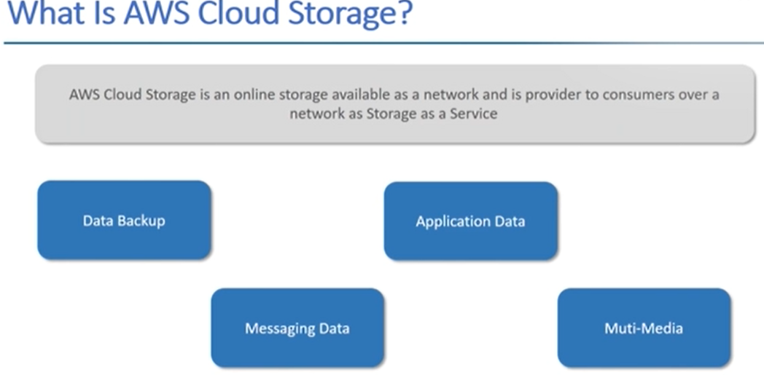

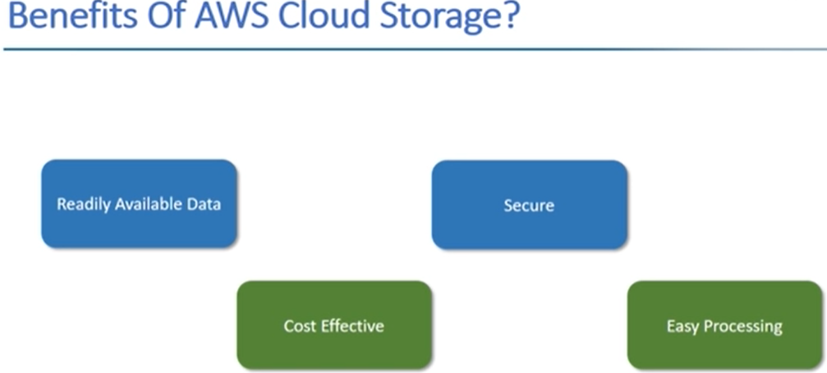

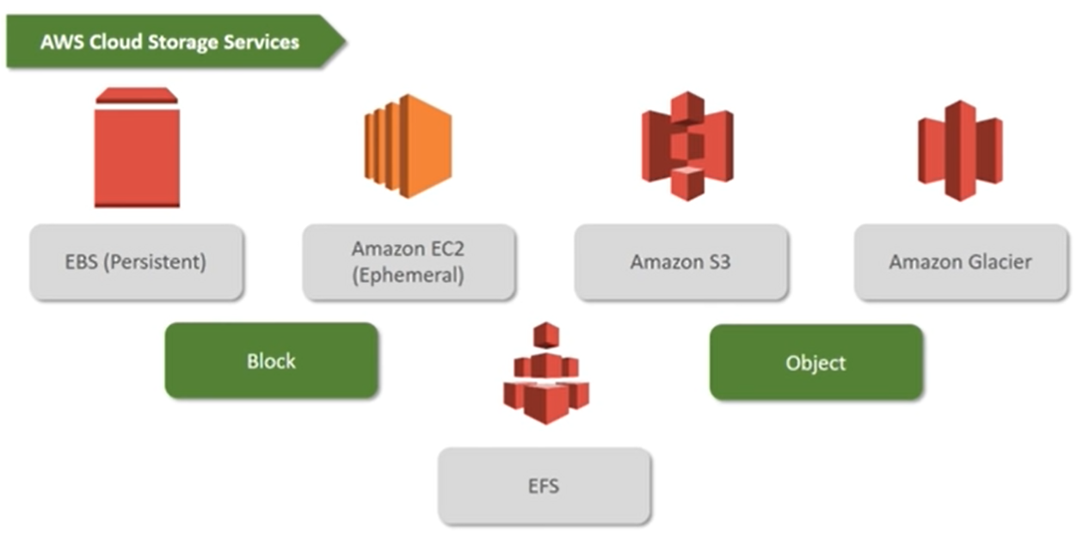

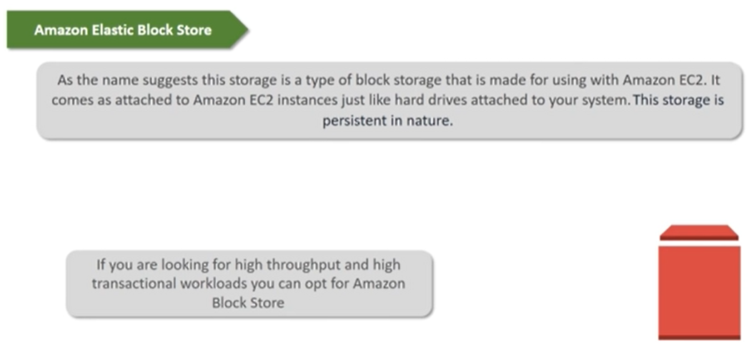

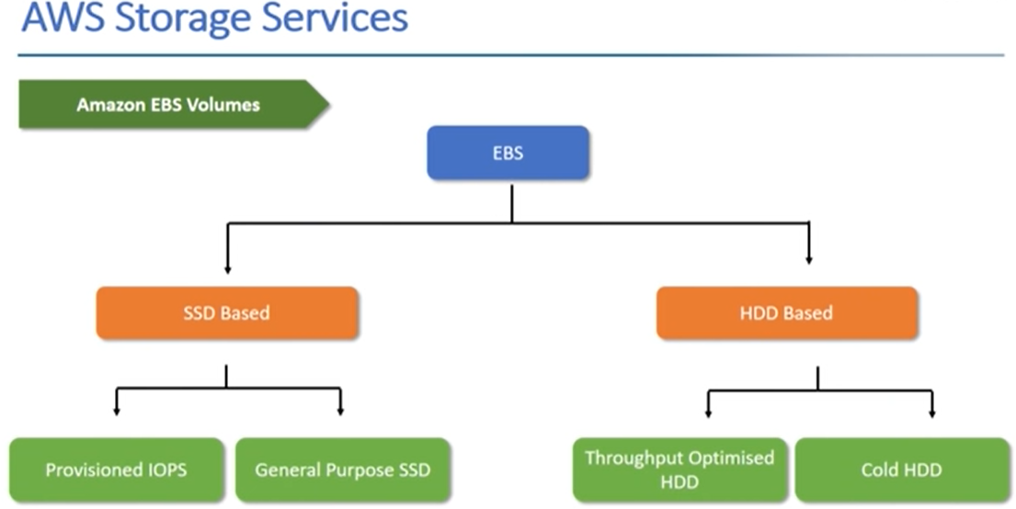

SSD – small kind of data handle

Provisional – intentional data will be handle – point data - critical

General Purpose – not critical

HDD – large kind of data handle

Throughput – fast data process

Cold - slow data process

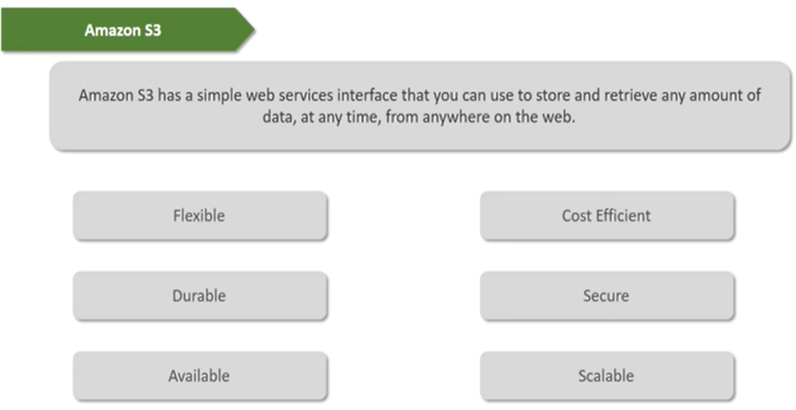

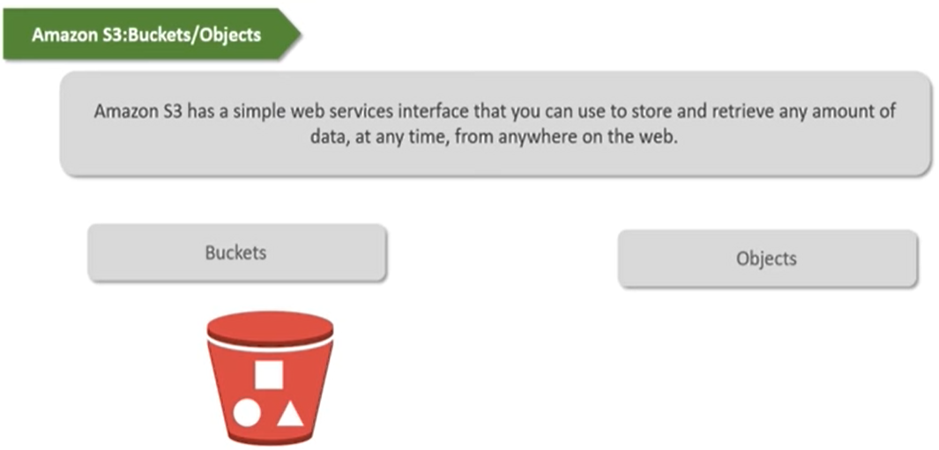

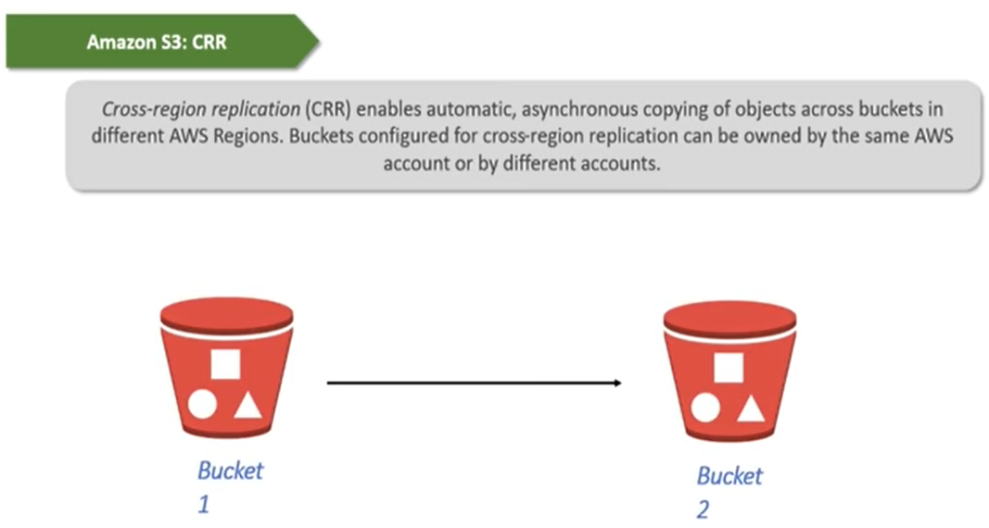

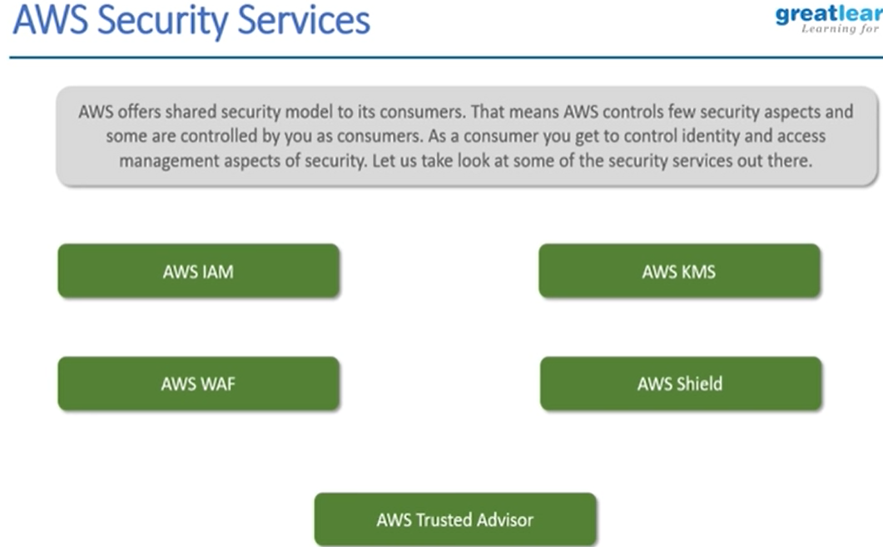

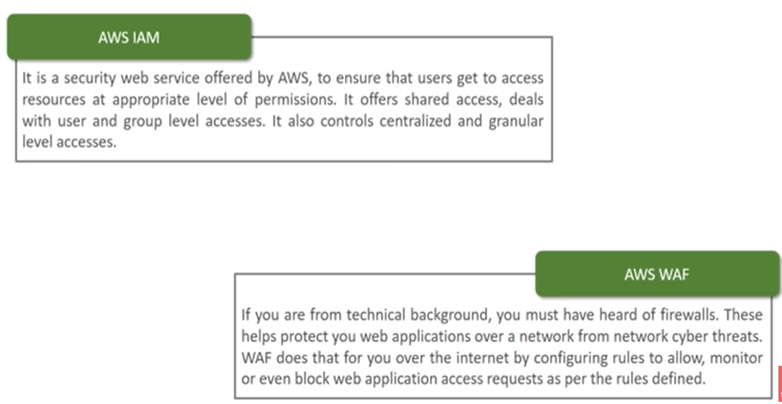

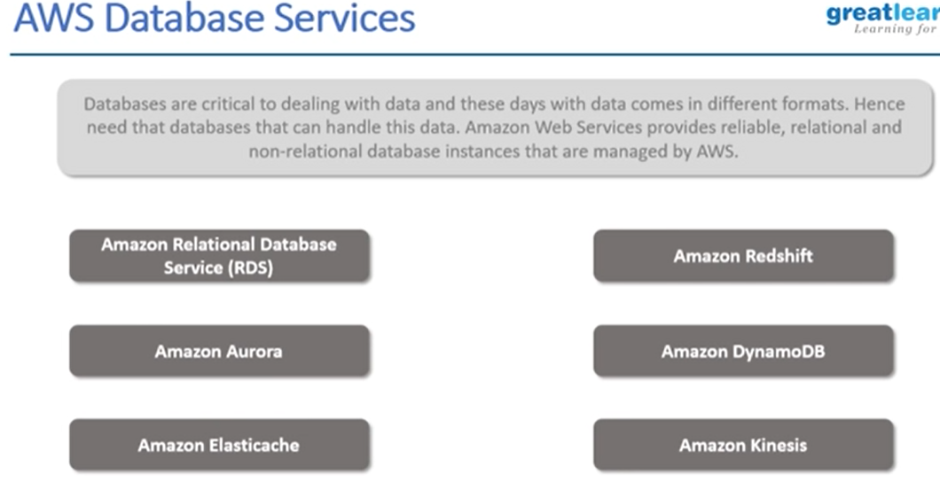

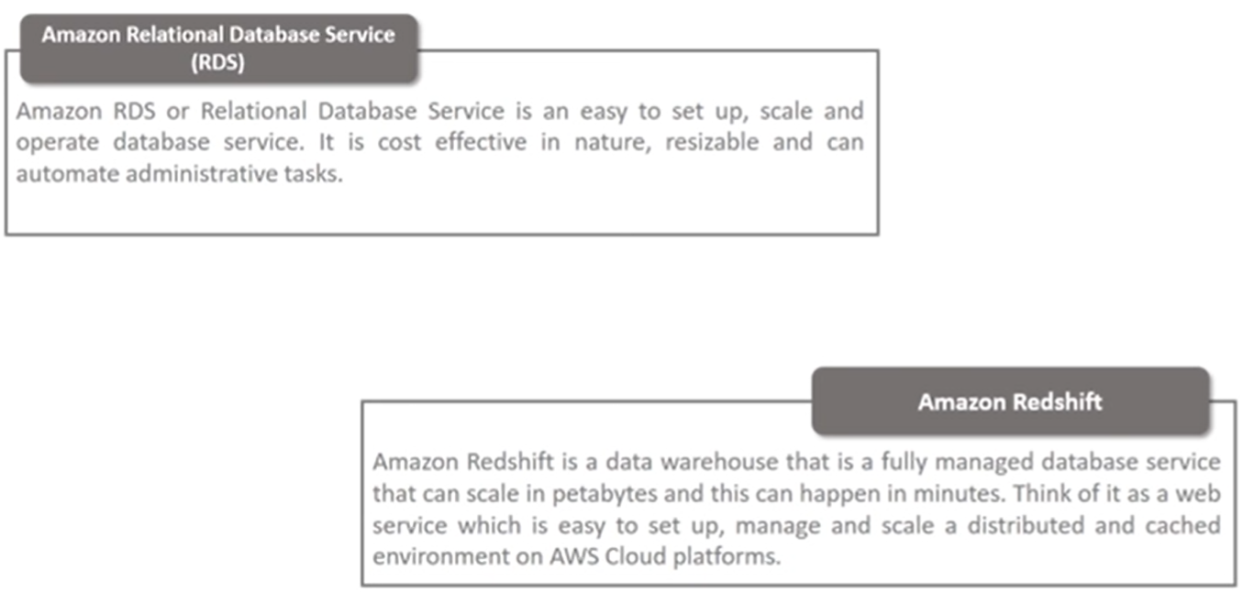

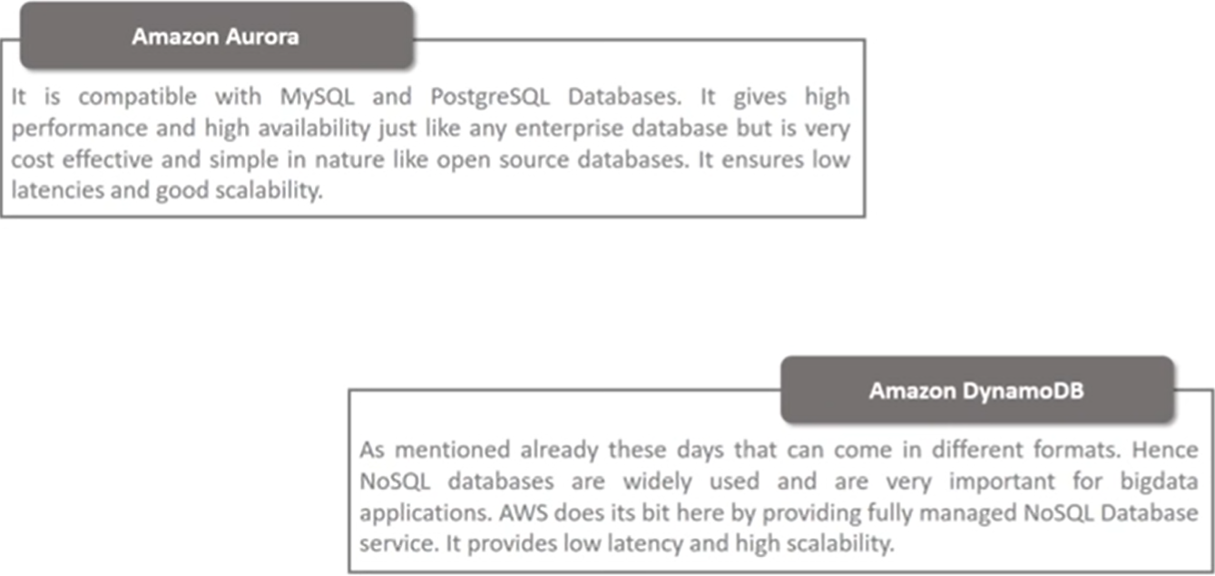

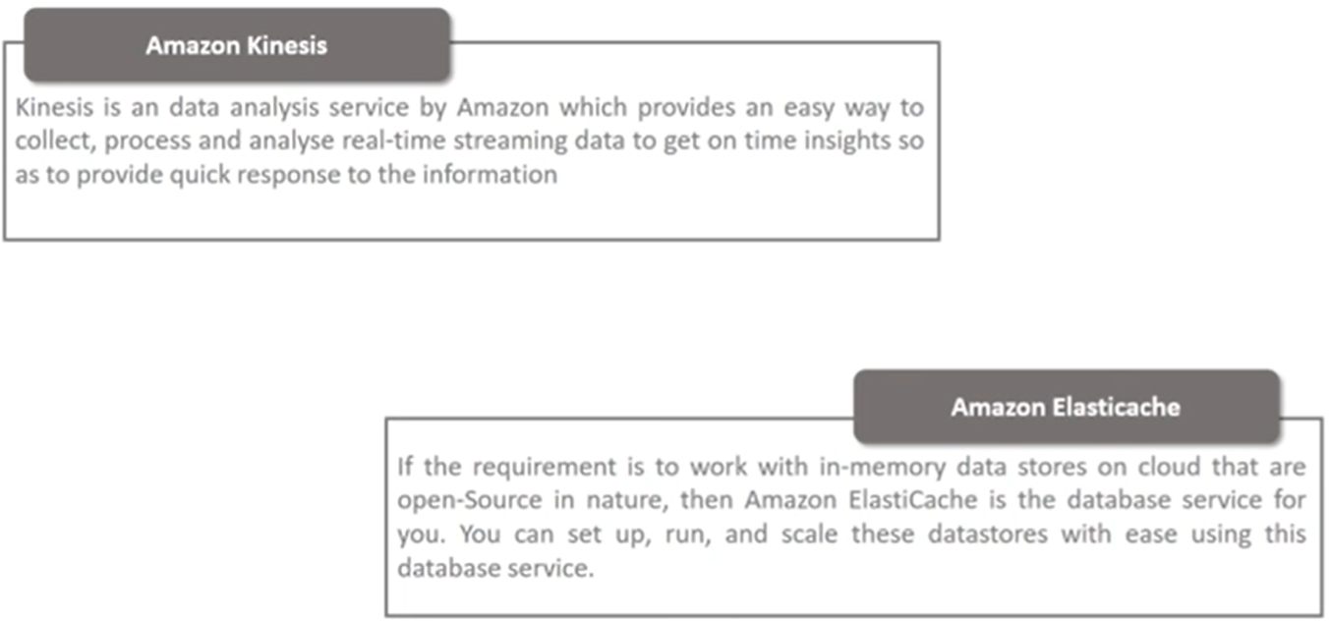

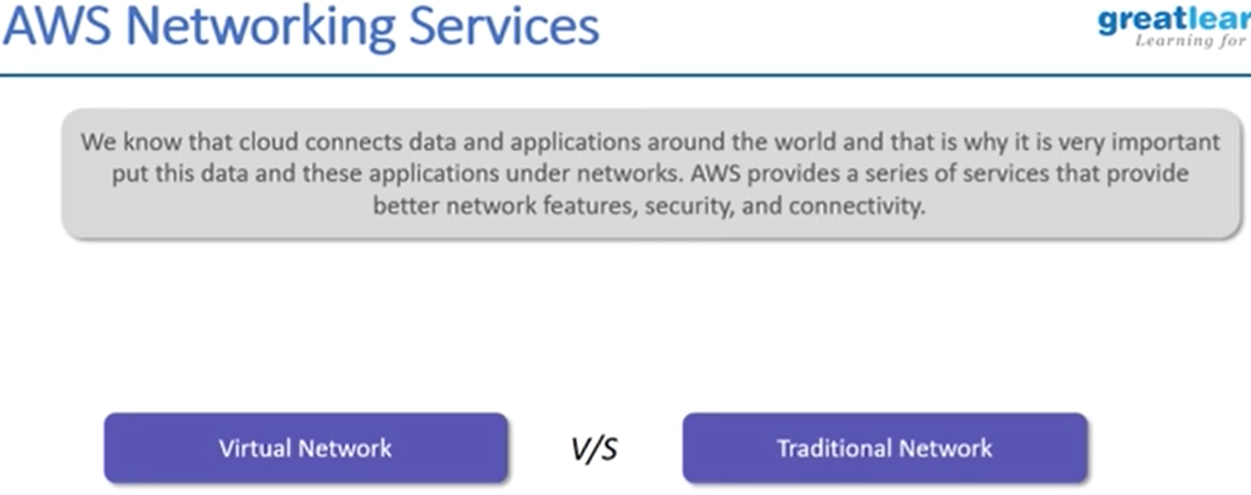

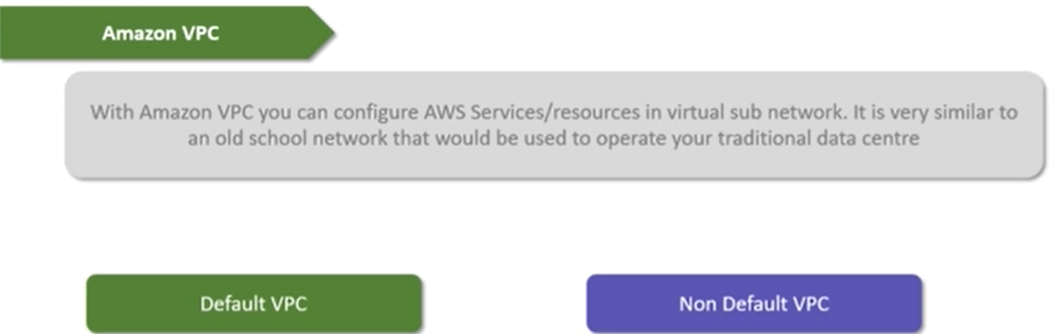

Project :

